Create a Module or Add the eBook to an Existing Module
- Within a course in Canvas, navigate to the Modules tab.
- If no Modules exist, create one by clicking +Module and providing a name for your module.
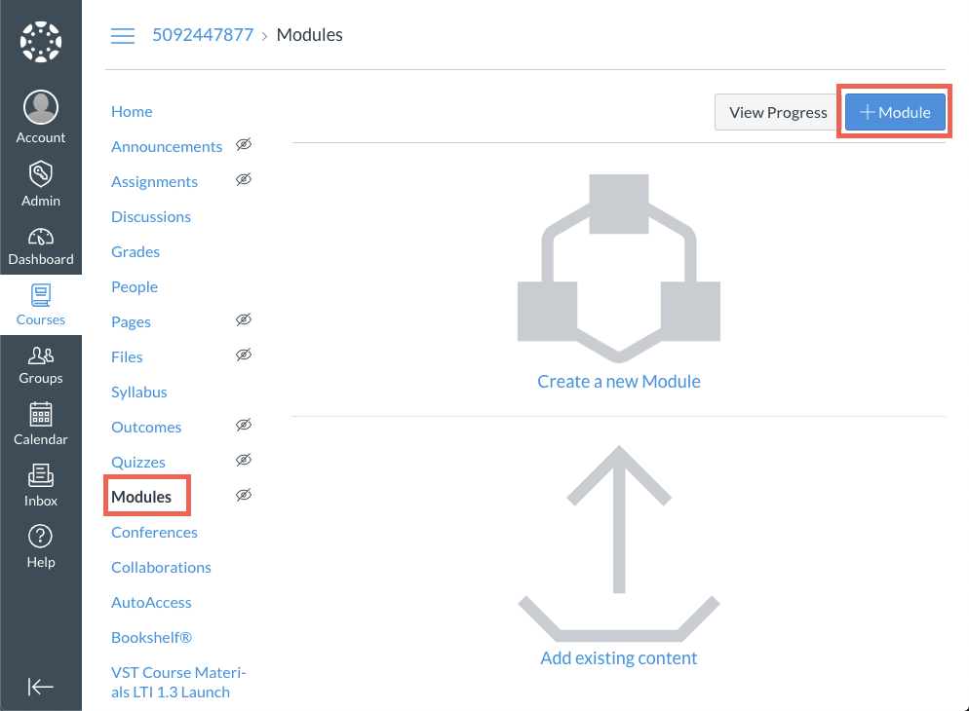
- Navigate to the new or existing Module where you will add the eBook link. Click the + button to add an item.
- From the + drop-down menu, click External Tool, then BookShelf by VitalSource. Note: Your LMS admin may have named the tool something else. Confirm the tool name before making your selection.
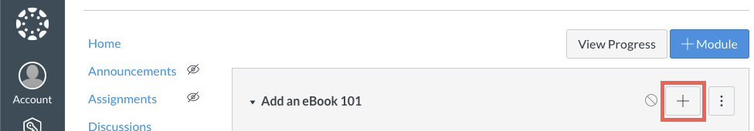
- The URL will be auto-populated. Note: The url should be something similar to https://bc.vitalsource.com/books
- The Page Name will be auto-populated, but you can edit it.
- Check the Load in new tab box.
- Click Add Item.
Below is an image that shows the entire process in one image.
