Start by logging in to your Cal Poly Pomona  Canvas page with your Bronco name and  password. | 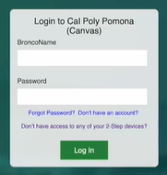

Click on one of your assigned courses.

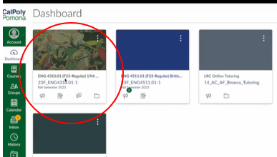
After selecting a course,  click on Instant Access Complete. | 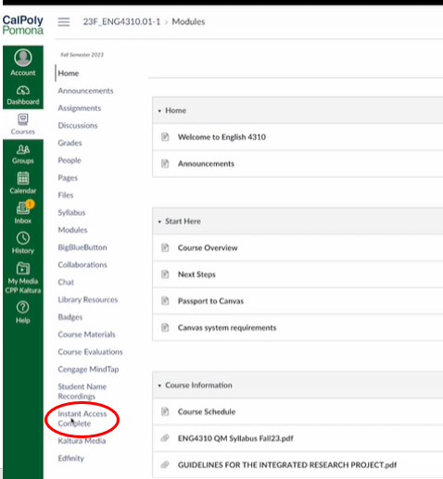
A course dashboard will load with all of your assigned course materials. In addition to ebooks, you might also have other types of course materials, like print items and courseware. To enter your course, simply click on the Launch Courseware button and follow the prompts.

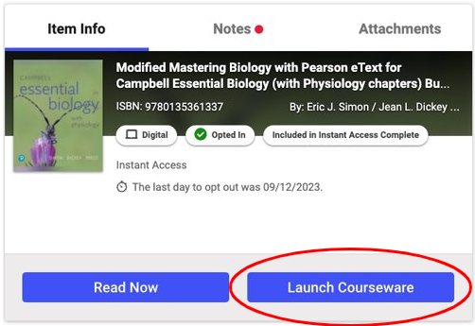

You Are Automatically Opted In, you do NOT need to opt in.

If you do not wish to participate in the program, log into Canvas and select any one of your courses. Click on the “Instant Access Complete” navigation option on the left-hand navigation menu. Your Instant Access Complete (IAC) dashboard listing all of your course materials will be displayed. Click on the “Want to Opt Out” button towards the top right corner. Make sure you get the email message confirming that you opted out. If you do not, please contact the bookstore to confirm. If you "Opt Out" of Instant Access Complete, you will be responsible for obtaining all your required materials on your own.

Changed your mind after add/drop deadline? Please visit the Instant Access Complete resource page and scroll down to the Pearson section to find out more. https://www.broncobookstore.com/facultyresources.asp?#INSTANT-ACCESS

For help with your Pearson Courseware, visit www.askpearsonsupport.com

