CAL POLY POMONA INSTANT ACCESS
Congratulations! Your course is part of the Instant Access Program which means you will have access on the first day of school! Instant Access delivers all required course materials for the course with the cost billed to your university account. If you are participating in this program, you do not need to buy course materials for this coruse as they will be provided to you. You get the required digital resources automatically uploaded to your Canvas account, so you can get started on assignments faster and hassle-free. You are now prepared to excel and can feel confident that you have been provided the most competitive pricing available, auto added to your student account bill.

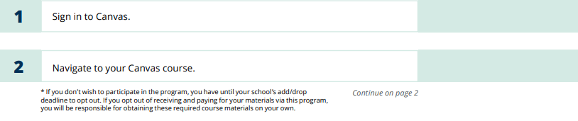
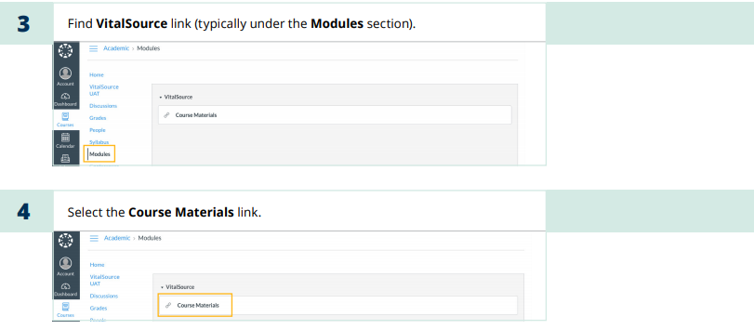

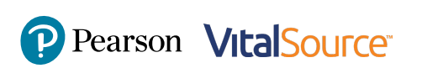
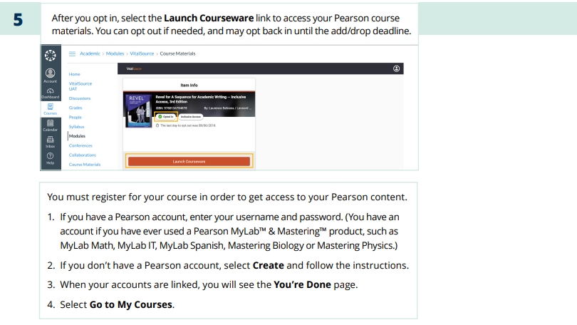
Need help?
For help with your Pearson Courseware with Canvas, visit https://support.pearson.com/getsupport/s/

If you do not wish to participate in the program you have until Septemer 3, 2021 to "Opt Out". If you "Opt Out" of receiving and paying for your materials via this program, you will be responsible for obtaining those on your own. These are required materials for the course.

Opt Out Deadline
September 3, 2021

