ITEM CARDS in CANVAS:

Opted Out student for current term. Item card shows ‘Buy Now’ (this is via the bookstore VS White Label Store). And Redeem Code, this is the code that students get via VitalSource white label store/Bookshelf.

The item card for opted out students begins to show this within 24 hours of the opt out date passing in Verba Connect (bookstore sets this up).

The card flips for students post opt out period only, not before. So if a student opts out prior to the opt period ending, the card remains as ‘launch courseware’ until post opt period ending.

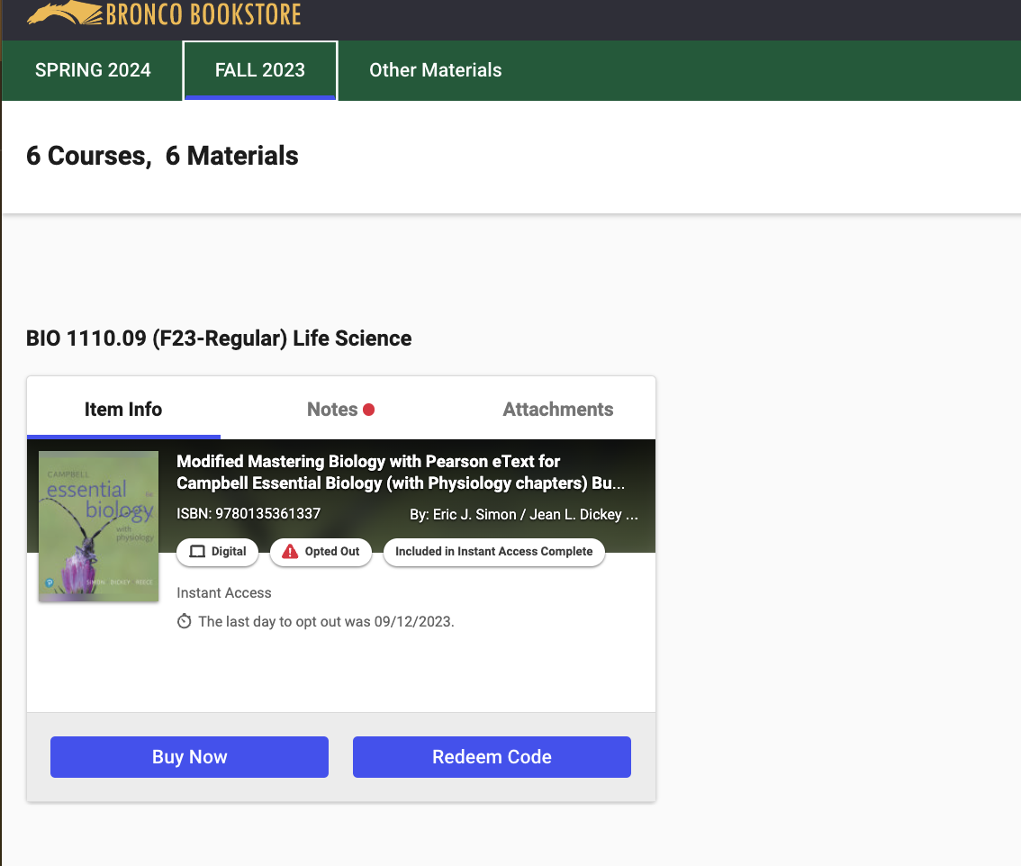

TO PURCHASE AFTER OPT OUT: Once clicking buy now you go to this page:

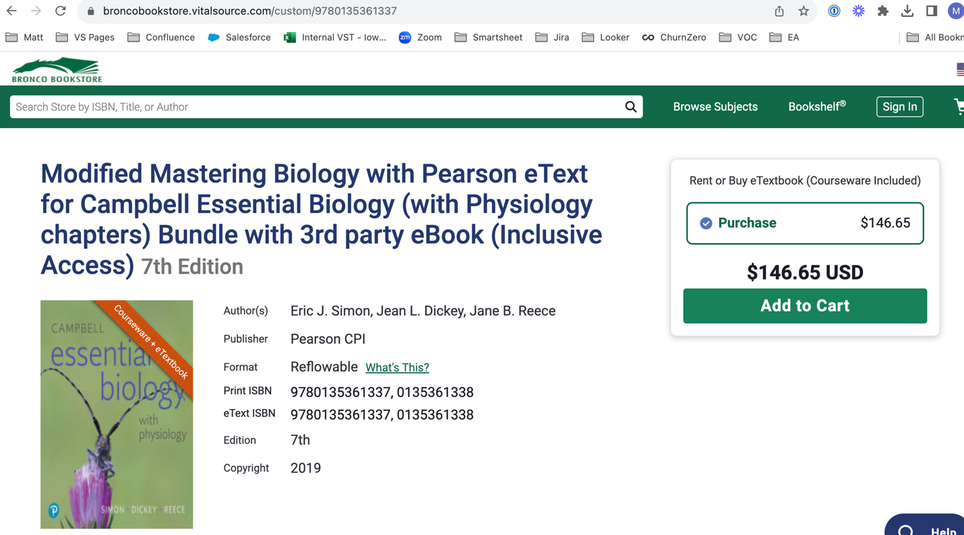

Regular check out from there, once you are done within bookshelf:

Support notes about this: https://support.vitalsource.com/hc/en-us/articles/222935067-How-do-I-redeem-my-Publisher-Access-Code-

However, for PI students who purchase this way after the opt out period ends will automatically get their Launch card switched from buy now to ‘launch courseware’ and they will be able to access again via Canvas.
If students do get the code from bookshelf and the item card in Canvas hasn’t switched back yet, they can use the ‘redeem code’ button on the item card in canvas. (NOTE: Students shouldn’t need to do this…but it is the backup method).

Opted in student item card. Read now takes students to VS Bookshelf to read the eBook.
Launch courseware takes students to the appropriate Pearson course setup by the instructor.

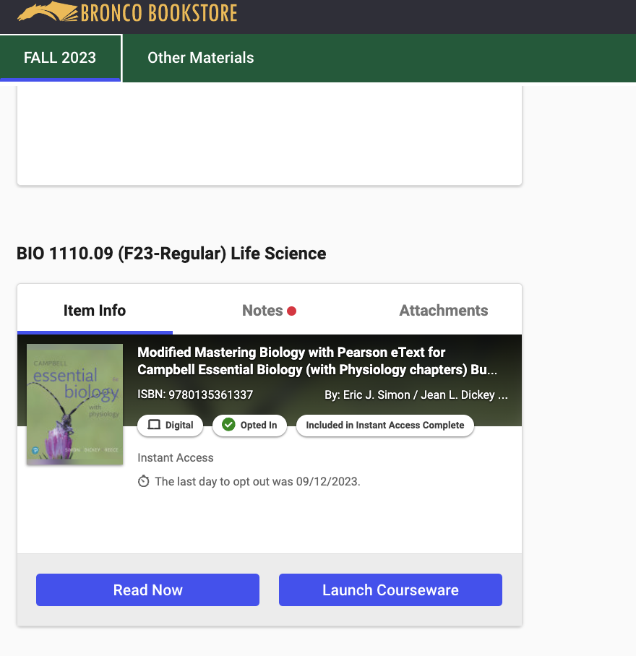

OPT OUT BUTTONS – 2 ways:

Via Canvas VS Tool/Item card pages: Opt out button is in the upper right corner of the students landing page in Canvas.

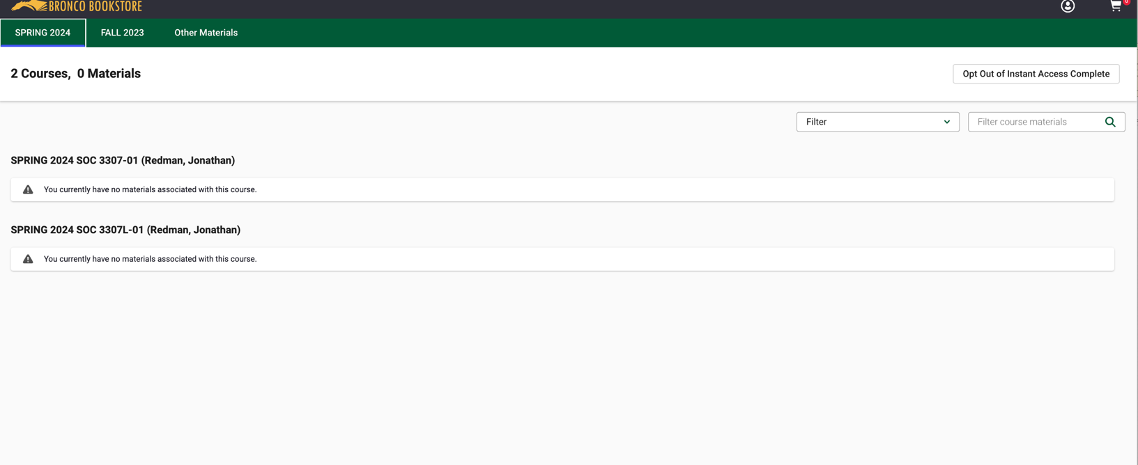

OPT OUTS CONTINUED:

Via the email sent by the bookstore via Verba Connect.

